We are heading to Tobermory on 2 different Weekends this summer.
Lots of Fun and Great Diving. Join us for one or both.
Capacity Limited to 12 Divers per Weekend
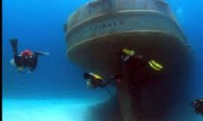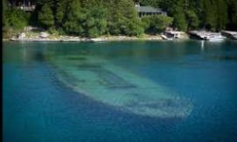
Details
2 WEEKENDS TO CHOOSE FROM
Fri July 7, Sat July 8, Sun July 9, 2023
and / or
Fri Aug 18, Sat Aug 19, Sun Aug 20, 2023
Each weekend:
Friday is Travel Day and Check-in to Accommodations at the 100 Acre Lodge
Diving
Sat 8:30 am Departure 3-4 Dives
Sun 8:30 am Departure 3-4 Dives
Includes Friday and Saturday Night Accommodations
2 dive days, 3-4 dives per day
Weekend Cost: $550.00 + HST

BOOKING IS EASY
CLICK HERE

