Join us for a great day of diving out of Penetanguishene with Captain Steve and Crew onboard the Georgian Explorer on one or both of 2 dates we have booked this summer.
Capacity Limited to 12 Divers
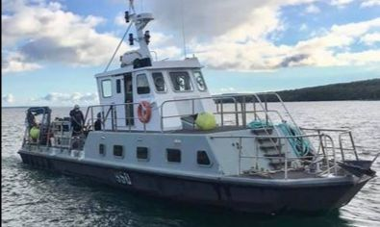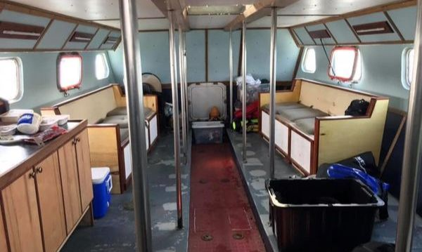
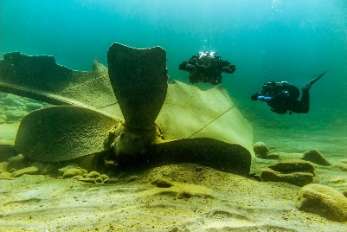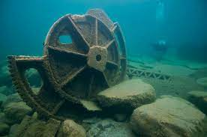
Details
2 DATES TO CHOOSE FROM
SATURDAY JUNE 24,2023 and/or SUNDAY SEPTEMBER 24,2023
Sat 8:30 am Departure 3-4 Dives
Incl Coffee and Snacks Upon Arrival, Hot Lunch, Drinks
Cost: $185.00+ HST

BOOKING IS EASY
CLICK HERE

